**Create and run a workflow runbook**

**Runbooks** serve as repositories for your custom scripts and workflows.

They also typically reference Automation shared resources such as credentials, variables, connections, and certificates.

**Work done by: Jilani**

**Source:** [Exercise - Create and run a workflow runbook - Training | Microsoft Learn](https://learn.microsoft.com/en-us/training/modules/explore-azure-automation-devops/11-exercise-create-run-workflow-runbook)

**Prerequisites:**

1. Need an azure automation account with active subscription

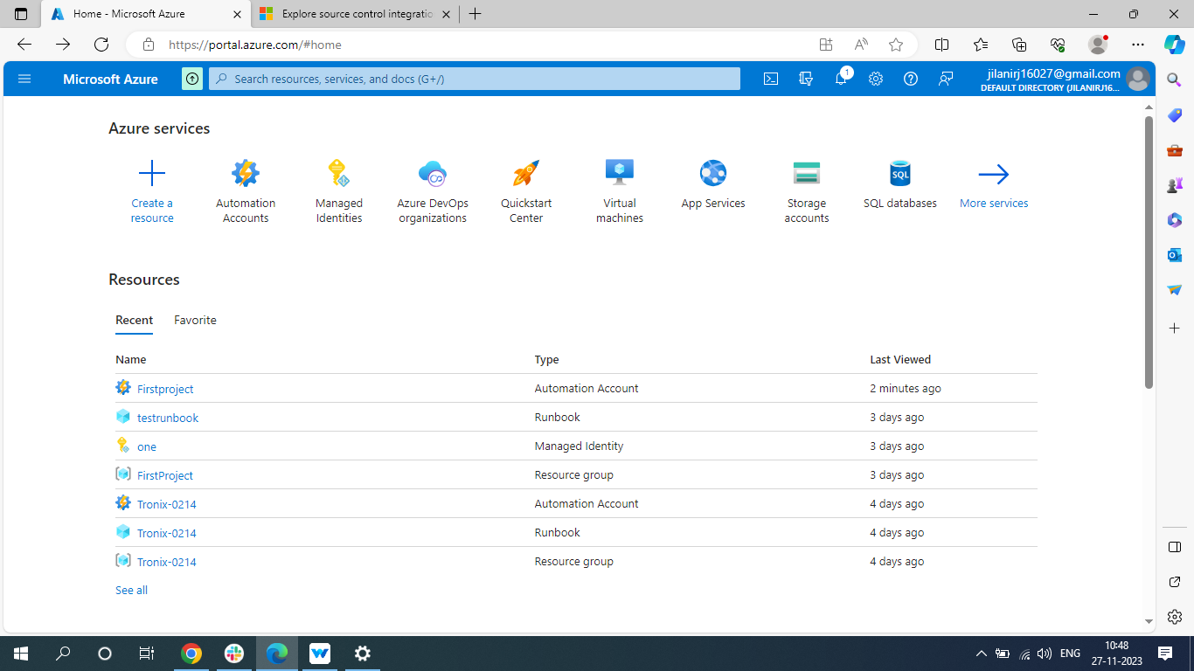



1. **Sign in to the**[**Azure portal**](https://portal.azure.com/)**and navigate to your Automation account.**

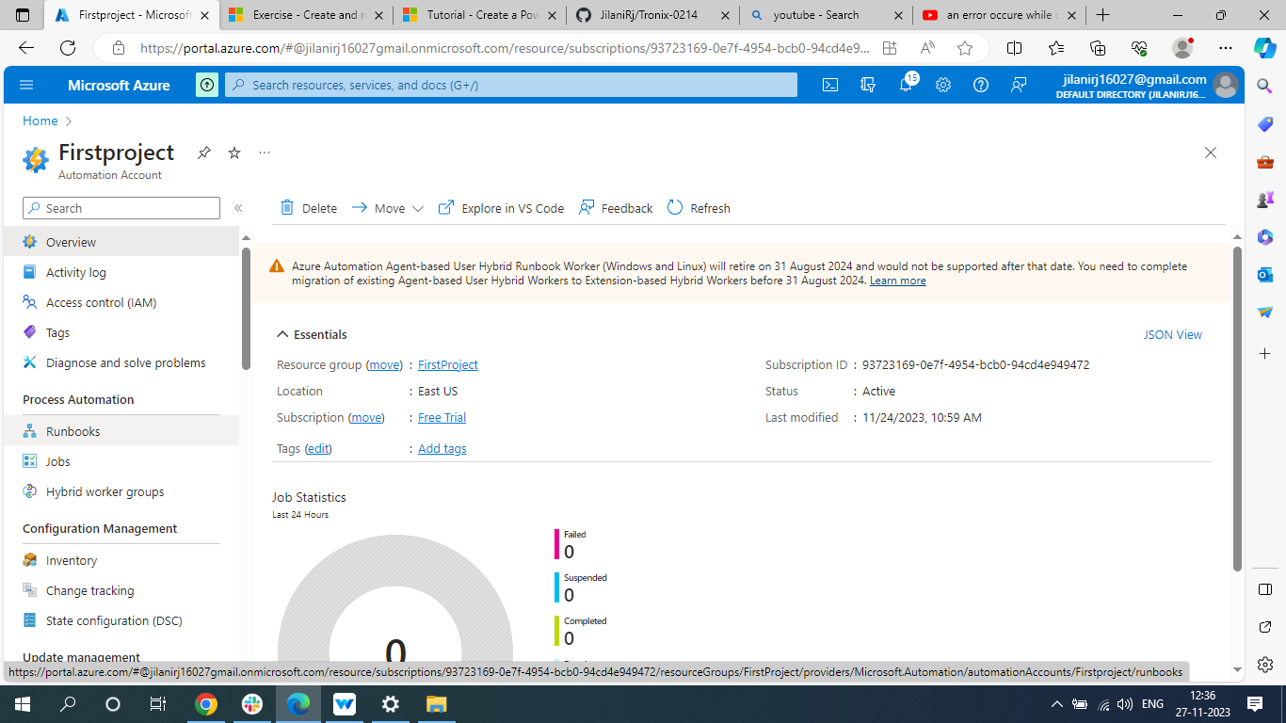



**Click on runbook**

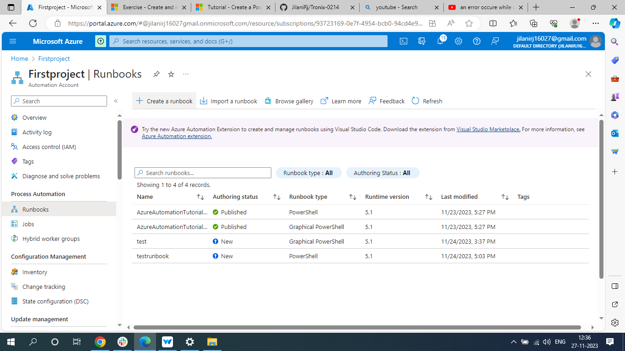



**Now click on +create a runbook which is at the top**

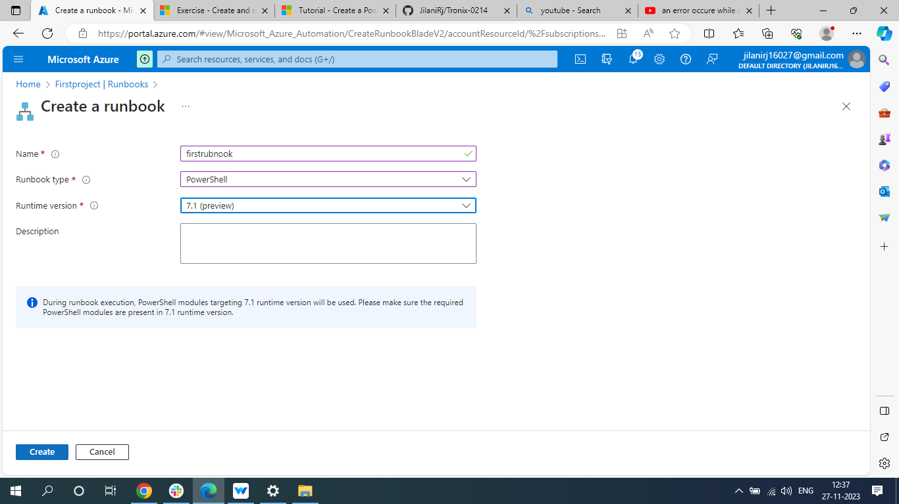



**Give name, runbook type (here we selected PowerShell because our code is in PowerShell) select runtime version and then click on create.**

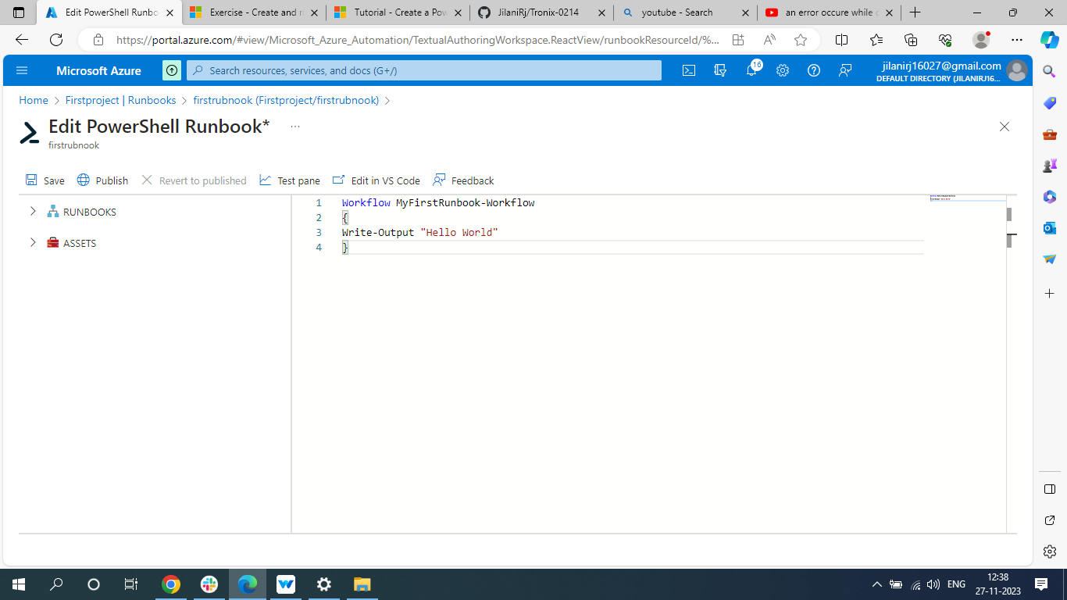



**Copy and paste the code here and click on save and then click on test pane**

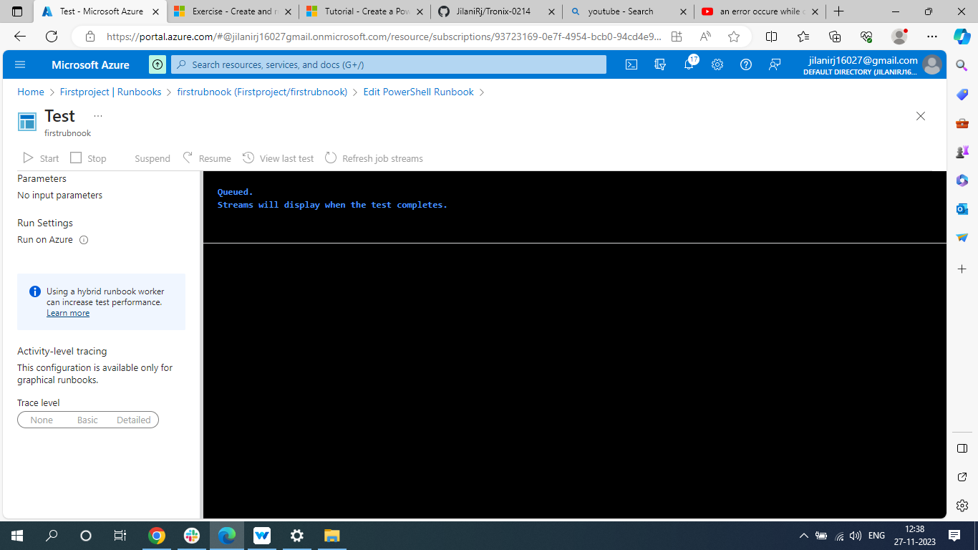



**Click on Start**

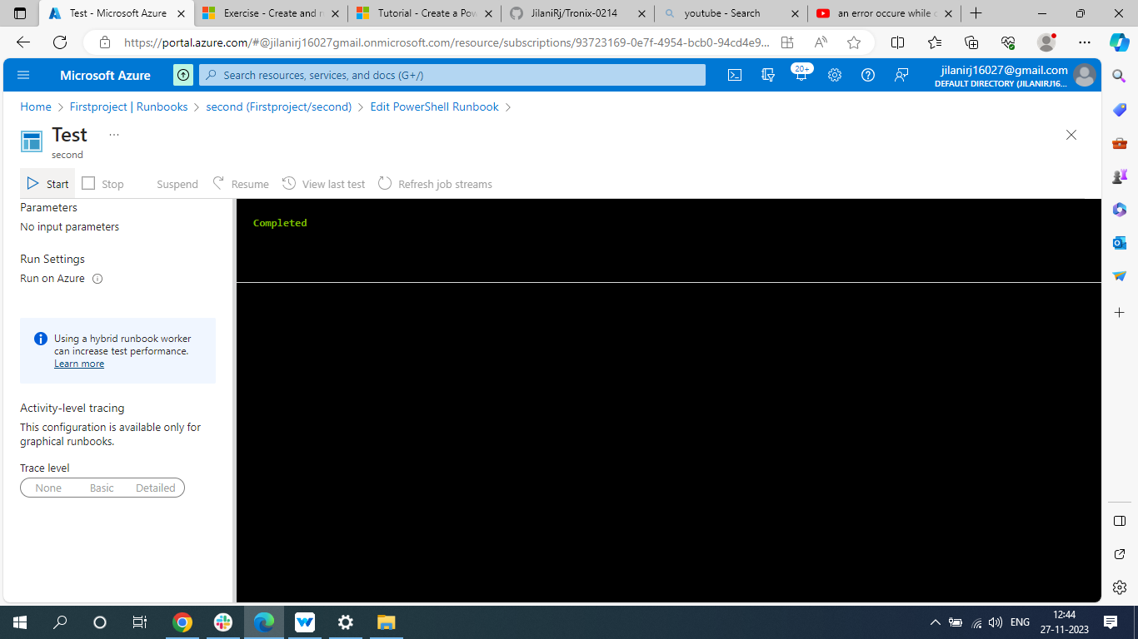



**Then it will show as completed.**

**Now click on edit PowerShell.**

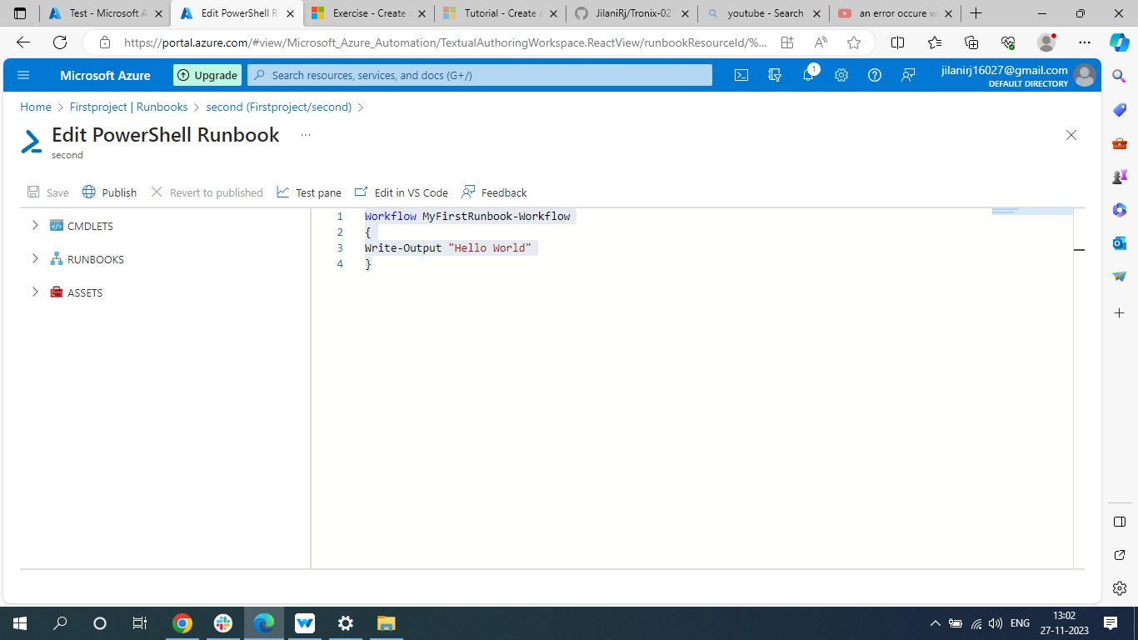



**As it is successful now click on publish**

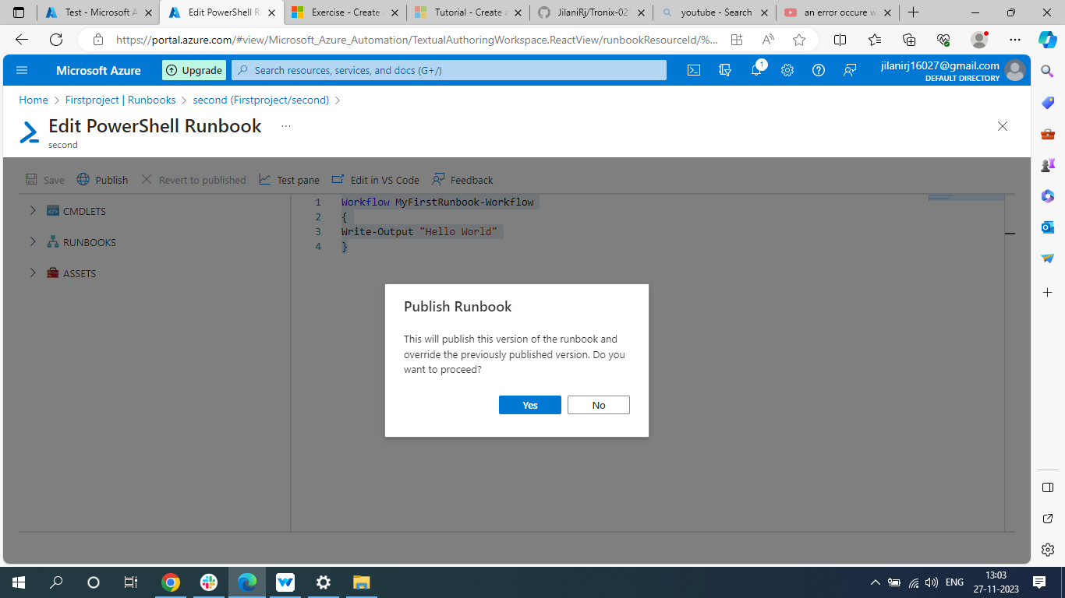



**Click on Yes**

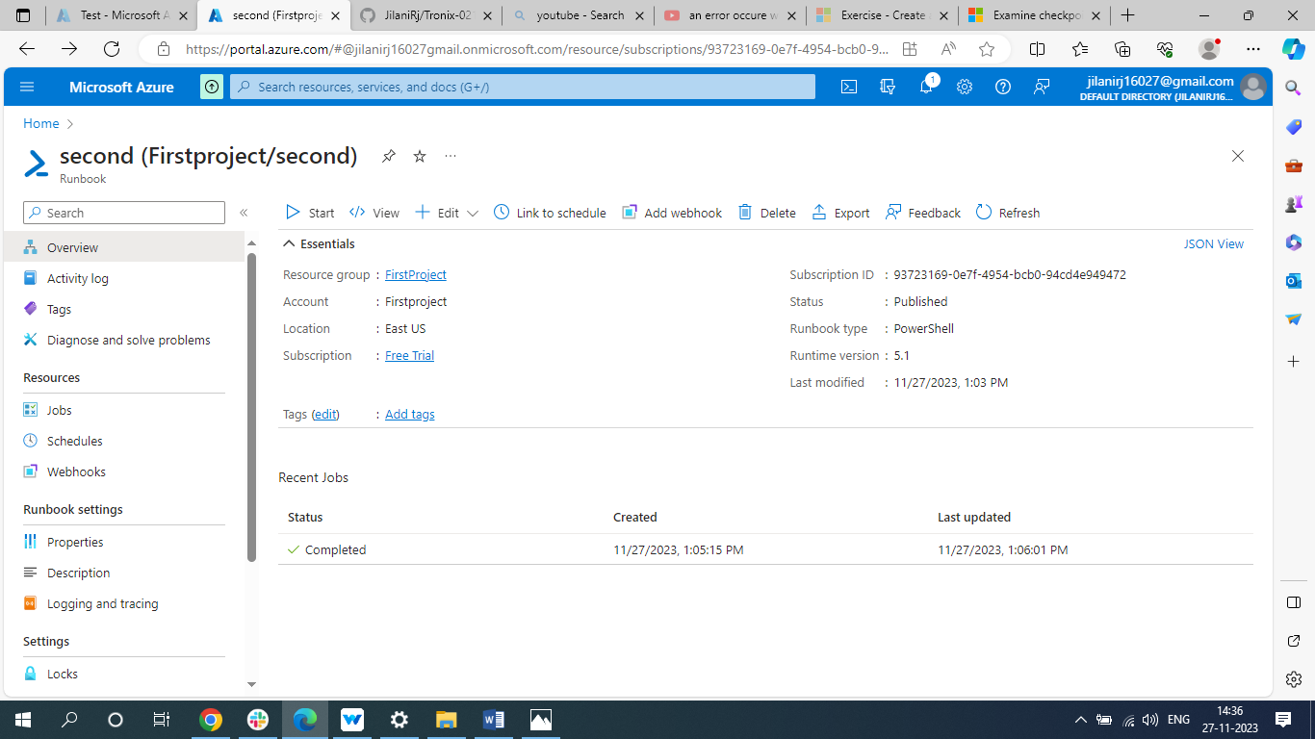



**Now you can see the status as published.**

**click on start**

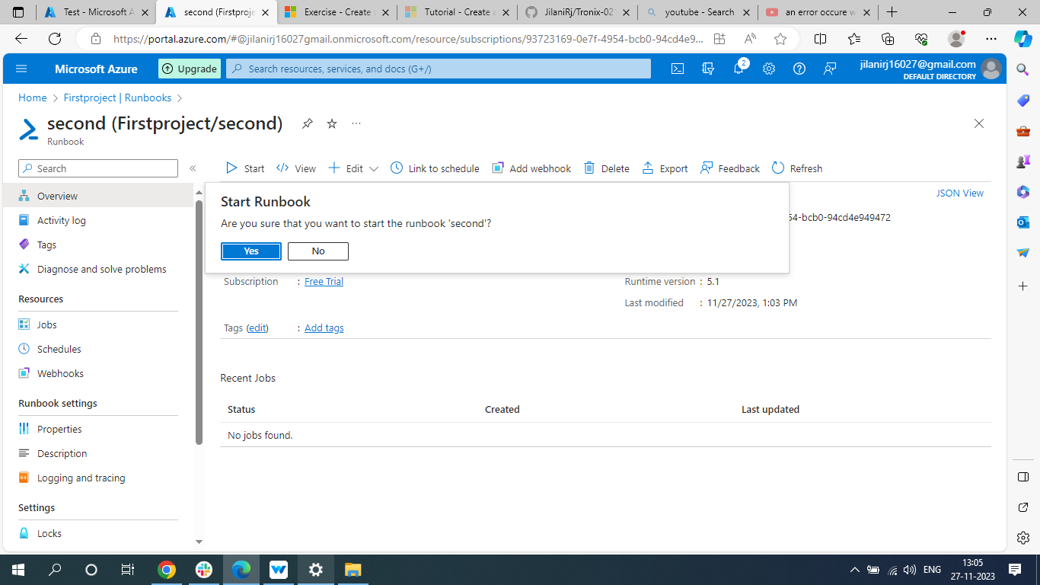



**Click on Yes.**

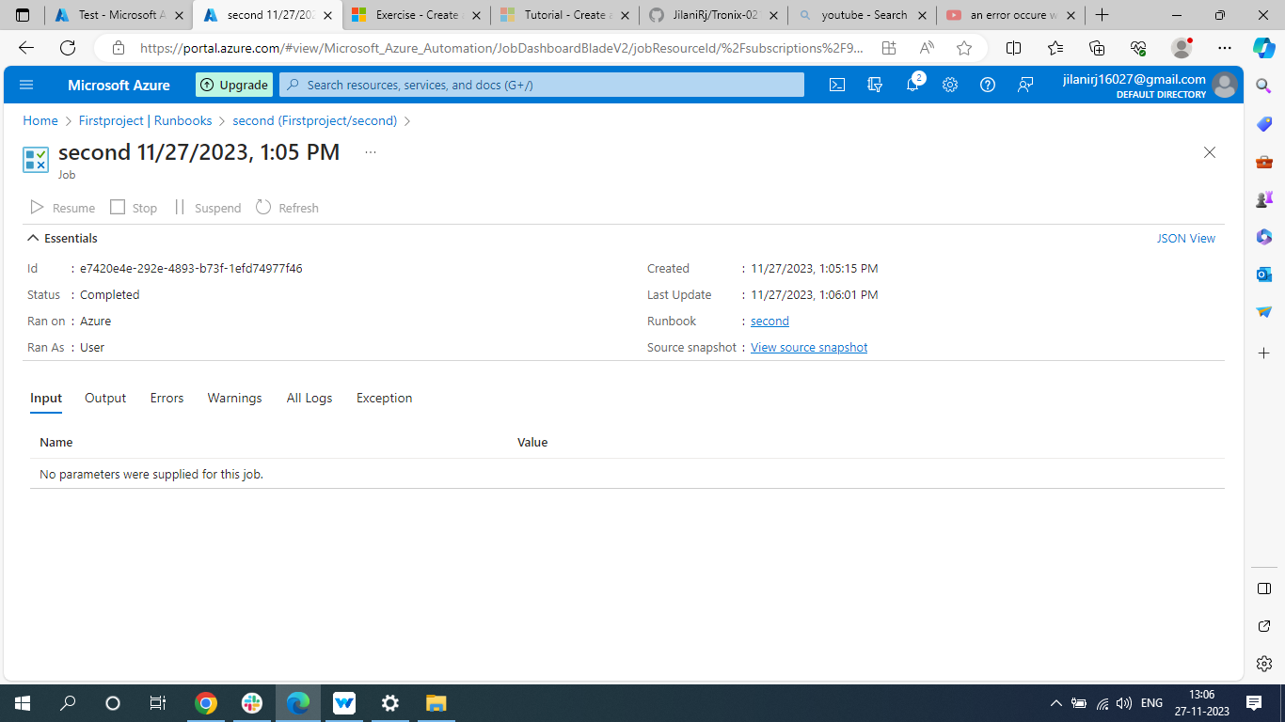

**When you click on Yes you will be directed to this page**

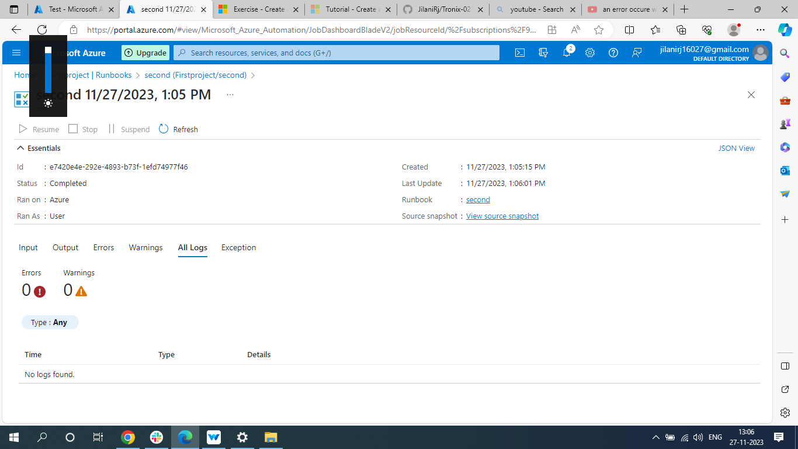



**You can click on All logs there you can see if any errors are there.**